Project information:

Idea:

Catch simple issues before code review using pre-commit. Pre-commit uses git hooks in order to catch your little typos before they hit the git tree. Automatically format your code, run a linter, type check, check config files, and more.

Githooks allows you to run set automated actions on the trigger of a push, commit, merge

# Pre-Commit

checks before the code is committed.

* <https://pre-commit.com/hooks.html>
* <https://www.youtube.com/watch?v=DPT9mNvGfH4>7 <https://www.youtube.com/watch?v=Wmw-VGSjSNg>
* <https://www.atlassian.com/continuous-delivery/continuous-integration/git-hooks>
* 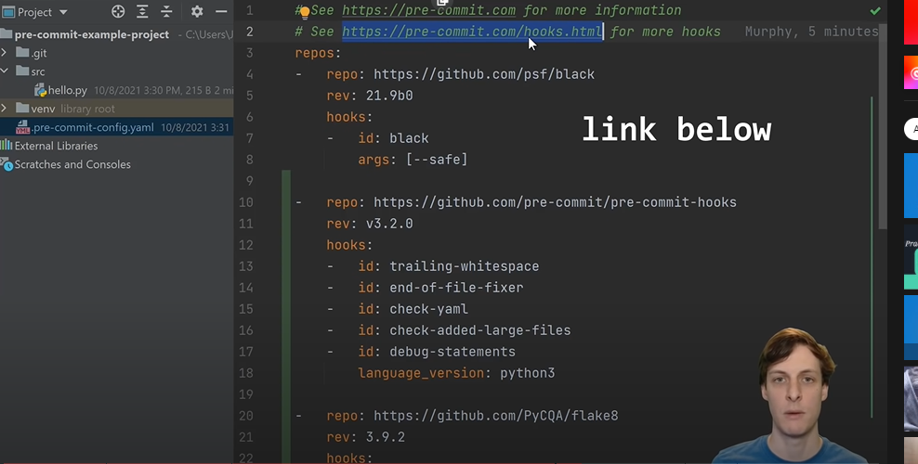

**Software to use with Pre-Commit:**

* Black
  + Formats the code, then changes the format and asks you to readd and recommit.
* Trailing whitespace
* End of line fixer
* Check yaml
* Check added large files
* Debug statements
* Language version

**Run linter**

Flake8

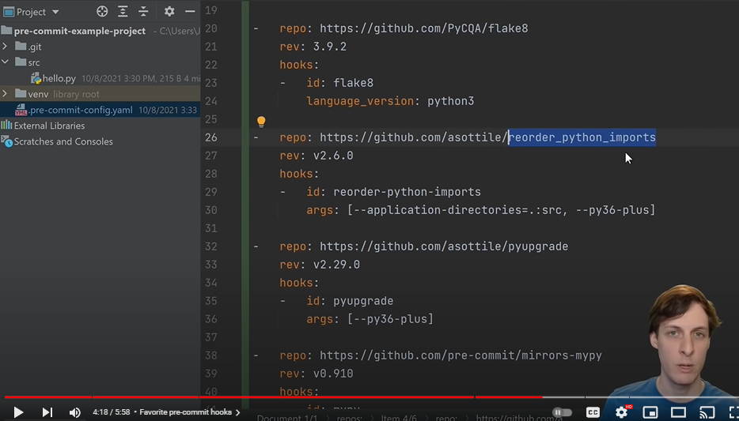

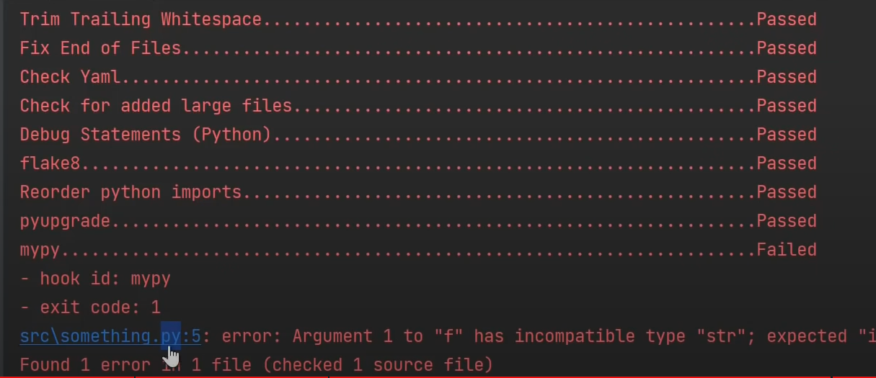

# Example of pre-commit failure

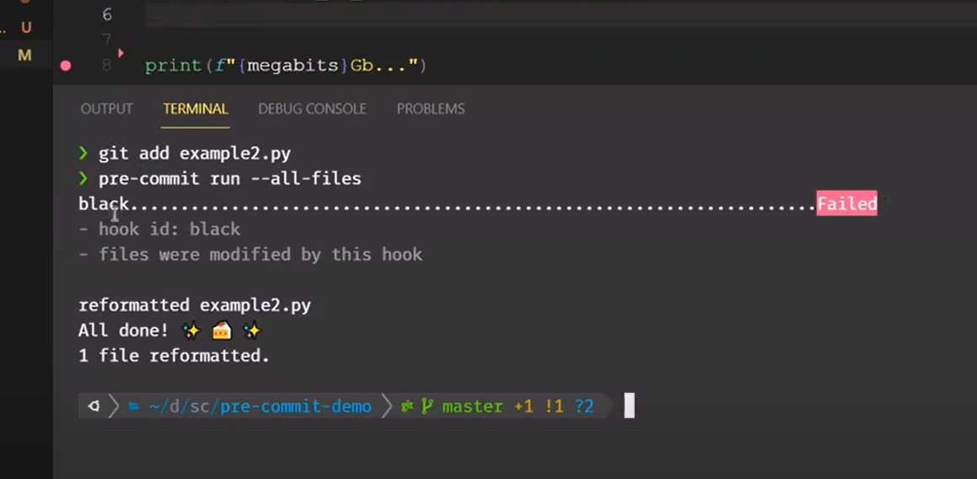

### [**github.com/asottile/reorder_python_imports**](https://github.com/asottile/reorder_python_imports)

* reorder-python-imports - This hook reorders imports in python files.

### [**github.com/asottile/pyupgrade**](https://github.com/asottile/pyupgrade)

* pyupgrade - Automatically upgrade syntax for newer versions.

### [**github.com/pre-commit/mirrors-mypy**](https://github.com/pre-commit/mirrors-mypy)

* mypy – Type checker

Comments on youtube:

* 1. Git hooks are a convenience for the developer and to encourage cleaner commit history. As mentioned, they do not substitute for CI jobs which also run these commands and prevent any merges on the remote if there are failures.
  2. You absolutely can! Pre-commit allows you to pick the stage to run each script at, so you can just put them all to pre-push in your config and voila!

Sources:

<https://www.youtube.com/watch?v=psjz6rwzMdk> *this video is the one

*Sources to review:*

[*https://www.google.com/search?client=opera-gx&q=githooks+slack+failed+commit+pylint&sourceid=opera&ie=UTF-8&oe=UTF-8*](https://www.google.com/search?client=opera-gx&q=githooks+slack+failed+commit+pylint&sourceid=opera&ie=UTF-8&oe=UTF-8) *– carry on reviewing each website*

[*https://www.youtube.com/watch?v=pB_nmvjYGQM*](https://www.youtube.com/watch?v=pB_nmvjYGQM) *– this one is good, what I need.*

[*https://www.youtube.com/watch?v=GKT9-_oEDpw*](https://www.youtube.com/watch?v=GKT9-_oEDpw)

[*https://github.com/chriseldredge/git-slack-hook*](https://github.com/chriseldredge/git-slack-hook) *info*

[*https://towardsdatascience.com/keep-your-code-clean-using-black-pylint-git-hooks-pre-commit-baf6991f7376*](https://towardsdatascience.com/keep-your-code-clean-using-black-pylint-git-hooks-pre-commit-baf6991f7376) *similar idea*

[*https://www.vantage-ai.com/blog/speed-up-your-python-development-workflow-with-pre-commit-and-makefile*](https://www.vantage-ai.com/blog/speed-up-your-python-development-workflow-with-pre-commit-and-makefile) *background information on which checks are what*

[*https://www.youtube.com/watch?v=EvpZkdkp-v0*](https://www.youtube.com/watch?v=EvpZkdkp-v0) *commiting stuff and install*